2.09.01. - Landscaping Regulations
A. Nonresidential Landscaping Requirements These standards shall apply to all Nonresidential Zoning Districts and Special Zoning Districts. Any area within a PD, Planned Development district containing landscaping standards shall be regulated by the more restrictive standards.
Nonresidential Landscaping shall be required according to the following sections:
Table 13: Nonresidential Landscaping Requirements (Section References)
Section Number | Section Title
2.09.01. A.1 | Landscaping Along Street Right-of-Way
2.09.01. A.2 | Interior Parking Lot Landscaping
2.09.01. A.3 | Landscaping for Corner Lots
2.09.01. A.4 | Landscaping/Screening for Parking Lots Adjacent to Residential Areas
2.09.01. A.5 | Foundation Plantings for Buildings 50,000 Square Feet or Larger
2.09.01. A.6 | Landscaping for Nonresidential Areas Adjacent to Residential Areas
2.09.01. A.7 | Landscaping for Below-Grade Open Parking Structures in the Front Yard

1. Landscaping Along Street Right-of-Way. All commercial, industrial and other nonresidential uses shall comply with the following streetscape requirements:
a. Landscaped Edge. A landscaped edge shall be provided adjacent to all streets.
i. The landscaped edge shall be the following minimum widths, exclusive of street Right-of-Way.
(a) Landscape buffer width adjacent to Arterial Street, Freeway, or Expressway: Twenty (20) feet.
(b) Landscape buffer width adjacent to Collector Street: Fifteen (15) feet.
(c) Landscape buffer width adjacent to Local Street: Ten (10) feet.
ii. Within the landscaped edge, one (1) shade tree (3" caliper minimum) (per Table 15: Recommended Plant Material List) shall be planted per 30 linear feet of landscaped edge. The grouping or clustering of required trees to accommodate driveway spacing, utilities, drainage facilities, or similar site features is permitted.
b. Vehicle Headlight Screening Abutting the Landscape Edge. Where parking lots, drives, and access easements abut the landscaped edge, opaque evergreen shrubs (5 gallon minimum) shall be planted to form a contiguous buffer along the common boundary line. The required shrubs shall be provided to create a minimum four (4) foot tall screen within two (2) years of the date of planting.
c. If the parking lot is located 50 feet or more from the street Right-of-Way line, no shrubs or berms will be required unless needed for a headlight screen. (See 2.09.01. A.4 for possible additional landscaping requirements.)
d. The Applicant is also encouraged to plant a variety of ornamental trees and flowers in addition to the required plantings.
e. Any permeable surface not occupied by trees, shrubs, planting beds, signs or other permitted fixtures shall be planted with turf or other living ground cover. Crushed granite may be utilized within 2 feet of the back of curb. The Director of Development Services may approve additional areas with an approved landscape plan.
2. Interior Parking Lot Landscaping. Any nonresidential parking area which contains more than 20 parking spaces shall provide interior landscaping in addition to the required Landscaped Edge (2.09.01. A.1.a):
a. Interior Parking Lot Landscaping shall include all areas within the paved boundaries of the parking lot as well as planting islands, curbed areas, corner lots, parking spaces and all interior driveways and aisles except those with no parking spaces located on either side.
i. Landscaped areas outside of the parking lot may not be used to meet the Interior Parking Lot Landscaping requirement.
b. There shall be ten (10) square feet of Interior Parking Lot Landscaping for each parking space or fraction thereof.
c. Landscape islands shall be required at a minimum of every ten (10) parking spaces and at the end of each parking row. Each landscape island shall be a minimum of nine (9) feet in width and the depth of each island shall match the depth of the adjacent parking space. Each landscape island must contain at least one (1) shade tree (required 3" caliper minimum) or an ornamental tree (per Table 15: Recommended Plant Material List). The remaining area within the landscape island shall have groundcover consisting of natural landscape materials, such as Native Plantings or Ornamental Grasses with a Rock/Crushed Rock Landscape Base or Mulch Base.
d. All landscaped areas shall be protected by a raised six (6) inch concrete curb.
i. Pavement shall not be placed closer than five (5) feet from the trunk of a new tree unless a City approved root barrier is utilized. Existing trees shall be protected with an area equal to the area encompassed by drip lines.
e. Where an existing parking area is altered or expanded to increase the number of spaces to more than twenty (20), Interior Parking Lot Landscaping shall be provided on the new portion of the lot in accordance with the above standards.
f. The requirements listed above shall not apply to structured parking garages.
3. Landscaping for Corner Lots. Corner lots (Lot, Corner) at the intersection of Arterial Streets, Freeways, and Expressways shall comply with the following landscaping requirements in addition to the required plantings for the Landscaped Edge and Interior Parking Lot Landscaping:
a. A minimum of ten percent (10%) of the site area shall be devoted to landscaping;
b. A minimum 15-foot wide landscaped edge shall be located along all street Right-of-Way lines beginning at the corner and extending 175 feet or to the closest driveway.
i. Beyond this point, the landscaped edge may be gradually reduced (over a distance of 25 feet) to match the required landscape edge.
c. A minimum landscaped area of 900 square feet shall be located at the intersection corner of the lot.
i. This landscaped area shall be provided within an area measured a minimum distance of 40 feet from the projected corner of the intersection on both sides of the lot.
4. Landscaping/Screening for Parking Lots Adjacent to Residential Areas. Where parking is within 50 feet of residentially zoned property and is not screened from view by a wall, berm or other screen, a continuous screen of shrubs (5 gallon minimum at the time of planting and planted in planting beds) must be placed adjacent to the parking. The required landscaping shall comply with the following regulations:
a. The required shrubs shall create a minimum four (4) foot tall screen within two (2) years of the date of planting.
5. Foundation Plantings for Buildings 50,000 Square Feet or Larger.
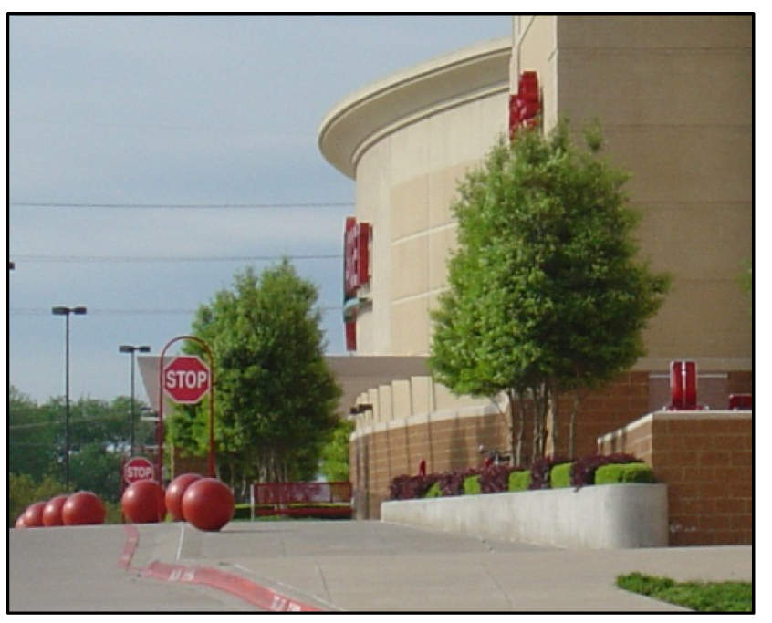
Figure 2: Building with
Foundation Plantings
a. Foundation plantings are required for buildings or groups of contiguous buildings that are 50,000 square feet or larger.
b. One large tree [three (3) inch minimum caliper] shall be required for every ten thousand square feet of gross building area.
c. These trees shall be planted within thirty feet (30') of the front facade.
d. These plantings are intended to break up the large impervious areas.
e. Plantings required by this section are in addition to trees required by other sections of this UDC.
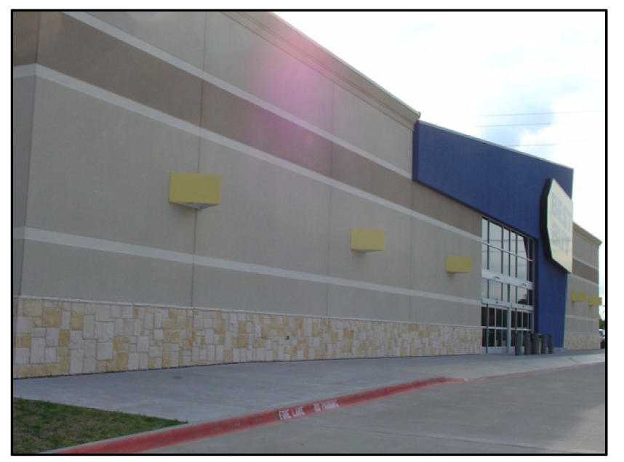
Figure 3: Building without Foundation Plantings
f. Trees can be grouped or planted in singular form.
g. These tree plantings should be placed so as not to impede sign visibility or pedestrian safety.
h. Trees intended for foundation plantings shall meet the following criteria:
i. Trees planted less than four feet (4') from the back of curb shall be planted in a tree grate with a minimum diameter width of four feet (4').
ii. Ornamental trees may be substituted for large trees at a building's foundation at the rate of five ornamentals for each required Large Tree (5:1).
(a) Ornamental trees shall have a minimum size of three (3) inch caliper.
(b) Multi-trunked trees will be required to meet a three (3) inch requirement based on standard nursery trade specifications.
iii. Trees may be placed in groups with appropriate spacing for the species.
iv. The requirements of this section may be reduced if approved by the City Council and when additional pedestrian features; such as, plazas, seating areas, fountains, and outdoor recreation facilities are provided. These facilities must occupy an area equal to or greater than five percent (5%) of the building's total square footage.
6. Landscaping for Nonresidential Areas Adjacent to Residential Areas. A 20-foot wide landscaped buffer shall be provided adjacent to land zoned for residential uses.
7. Landscaping for Below-Grade Open Parking Structures in the Front Yard.
a. Where below grade open parking is provided in the front yard setback of nonresidentially zoned properties, the required landscaping shall comply with the following regulations:
i. An 18-foot wide landscape edge shall be provided between the below-grade Parking Structure and the street Right-of-Way.
(a) The landscape edge is exclusive of street Right-of-Way; and
ii. The 18-foot landscape edge shall include a minimum 36-inch tall berm, measured from the property line after grading.
(a) The berm shall not exceed a 33 percent slope.
(b) One shade tree (3 inch caliper minimum) (per Table 15: Recommended Plant Material List) shall be provided for each 50 feet of street frontage within the landscape edge between the below grade open parking and the street Right-of-Way.
8. Measurement.
a. Trees with a single trunk shall be measured at 12 inches above the natural ground level.
b. If the trunk splits into multiple trunks below the 12-inch level, then the multiple trunk trees are measured by the following formula:
(i) Measure largest trunk circumference at 12 inches above the natural ground level.
(ii) Remaining trunks, measure circumference at 12 inches above the natural ground level and divided by two.
(iii) Add subsections (A) and (B) for total circumference, divide total by 3.14 to get caliper.
B. Residential Landscaping Requirements These standards shall apply to all Residential Zoning Districts. Any area within a PD, Planned Development containing landscaping standards shall be regulated by the more restrictive standards.
Residential Landscaping shall be required according to the following sections:
Table 14: Residential Landscaping Requirements (Section References)
Section Number | Section Title
2.09.01. B.1 | Multi-Family, Single Family Attached and Retirement Housing Landscaping Requirements
2.09.01. B.2 | Landscaping Requirements for Single Family Developments

1. Multi-Family, Single Family Attached and Retirement Housing Landscaping Requirements.
a. Landscape Edge. A landscaped edge shall be provided adjacent to all streets.
i. The landscaped edge shall be the following minimum widths, exclusive of street Right-of-Way.
(a) Landscape buffer width adjacent to Arterial Street Freeway, or Expressway: Twenty (20) feet.
(b) Landscape buffer width adjacent to Collector Street: Fifteen (15) feet.
(c) Landscape buffer width adjacent to Local Street: Ten (10) feet.
ii. Within the landscaped edge, one (1) shade tree (3 inch caliper minimum) (per Table 15: Recommended Plant Material List) shall be planted per 30 linear feet of landscaped edge. The Director of Planning may approve the grouping or clustering of trees to accommodate driveway spacing, utilities, drainage facilities, or similar site features.
iii. The number of required trees shall be calculated solely on the area of the required landscaped edge.
b. Shrub Buffer for Parking Lots and Drives. Where parking lots and drives abut the landscaped edge, shrubs (5 gallon minimum) shall be planted to form a contiguous buffer along the common boundary line.
i. The number of required shrubs shall be calculated solely on the area of the required landscaped edge.
ii. Shrubs shall be planted in planting beds.
iii. A berm may be placed within the landscaped edge in lieu of the required shrubs unless needed for a headlight screen.
iv. The berm must be 18 to 40 inches above the average grade of the street and parking lot curbs.
v. The slope of berm shall not exceed a 33 percent grade.
c. If the parking lot is located 50 feet or more from the street Right-of-Way line, no shrubs or berms will be required unless needed for a headlight screen.
d. The Applicant is also encouraged to plant a variety of ornamental trees and flowers in addition to the required plantings.
e. Any permeable surface not occupied by trees, shrubs, plantings beds, signs or other permitted fixtures shall be planted with turf or other living ground cover.
f. The Planning and Zoning Commission and the City Council may reduce the width of the required landscaped edge during Site Plan review when the reduction is required for a Public Improvement.
g. Parking areas shall be landscaped in addition to the required landscaped edge.
i. Twenty (20) square feet of landscaping for each parking space shall be provided within the paved boundaries including one (1) shade tree (3" caliper minimum) or ornamental tree (per Table 15: Recommended Plant Material List) per ten (10) parking spaces.
h. All landscaped areas shall be protected by a raised six (6) inch concrete curb.
i. Pavement shall not be placed closer than five (5) feet from the trunk of a tree unless a staff approved root barrier is utilized.
i. One (1) shade tree (3" caliper minimum) or ornamental tree per 1,000 square feet of required open space (e.g., required yards) shall be provided.
j. No site developed prior to the effective date of this section shall be required to conform to the landscaping requirements of this section unless the site is redeveloped or there is a thirty percent (30%) or more increase in the existing square footage of building area and/or reconstruction of the existing parking lot.
k. Additional Multi-family Landscape Requirements. The multi-family complex shall be landscaped in accordance with 2.09.01. Landscaping Regulations. If more than one apartment building is permitted to be placed upon a single lot, the following areas shall be landscaped:
i. A twenty (20) foot strip along the front and rear of the buildings as measured from the foundation.
ii. A fifteen (15) foot strip along all other sides of the buildings as measured from the foundation.
iii. That area adjacent to building corners determined by extending the front, rear, and side landscape limits to their point of intersection.
iv. Any additional landscape area that is needed to meet the City's requirements shall be indicated and fully described upon the plat.
2. Landscaping Requirements for Attached and Detached Single Family Developments.
A. Perimeter landscaping requirements.
a. Landscaped Edge. A landscaped edge shall be provided adjacent to all streets which lay on the perimeter of a residential subdivision.
i. The landscaped edge shall be the following minimum widths, exclusive of street Right-of-Way.
(a) Landscape buffer width adjacent to Arterial Street, Freeway, or Expressway: Twenty (20) feet.
(b) Landscape buffer width adjacent to Collector Street: Fifteen (15) feet.
(c) Landscape buffer width adjacent to Local Street: Ten (10) feet.
ii. Within the landscaped edge, one (1) shade tree (3" caliper minimum) (per Table 15: Recommended Plant Material List) shall be planted per 30 linear feet of landscaped edge. The Director of Planning may approve the grouping or clustering of trees to accommodate driveway spacing, utilities, drainage facilities, or similar site features.
iii. The number of required trees shall be calculated solely on the area of the required landscaped edge.
B. Landscaping requirements for attached and detached Single Family lots.
(a) Required Landscaping.
(1) Trees shall be planted to meet the total number of caliper inches referenced in the table below. Required large trees shall not be smaller than three (3) caliper inches; required small trees shall not be smaller than two (2) caliper inches in size. A minimum of one (1) large and one (1) small tree shall be located in the front yard of all residential lots. The remaining required trees may be placed in the front or rear of the residential lot.
Size of lot (sq. ft.) | Caliper Inches | Number of Shrubs
2,500—6,999 | 5 | 12
7,000—8,999 | 8 | 15
9,000—19,999 | 11 | 20
20,000+ | 14 | 25

(b) Location of trees.
(1) Trees may be approved for planting in the parkway by the Planning Director if they meet City standards for species, spacing, location, infrastructure clearance, and maintenance; absent such written approval, the planting of trees in the parkway shall not be allowed.
(2) Trees are to be placed in a location which does not interfere with overhead and/or underground utility easements.
(3) Trees are to be spaced so that at mature growth their canopies do not interfere with one another.
(c) Measurement.
(1) Trees with a single trunk shall be measured at 12 inches above the natural ground level.
(2) If the trunk splits into multiple trunks below the 12-inch level, then the multiple trunk trees are measured by the following formula.
(i) Measure largest trunk circumference at 12 inches above the natural ground level.
(ii) Remaining trunks, measure circumference at 12 inches above the natural ground level and divided by two.
(iii) Add subsections (A) and (B) for total circumference, divide total by 3.14 to get caliper.
(d) Additional vegetation requirements.
(1) Required shrubs shall be a minimum of three (3) gallons in size when planted and shall be planted in the front yard of all residential lots. Shrubs may be substituted with small trees when planted in the front yard.
(2) Solid vegetative ground cover or lawn for the entirety of the lot that is not otherwise covered by mulched planter beds, building(s) and/or driveway area(s).
(3) All landscaping required above shall be planted prior to issuance of the certificate of occupancy on the dwelling(s).
C. Landscape Maintenance Requirements
1. All plant material shall be maintained in a healthy and growing condition, and must be replaced with plant material of similar variety and size if damaged, destroyed, or removed.
2. Landscaped areas shall be kept free of trash, litter, weeds and other such materials or plants not a part of the landscaping.
3. An automatic irrigation system with rain and freeze sensors is required for all landscaping except for single family residences.
4. All cut areas front, side, and rear must have sod for erosion control.
5. Any Developer desiring to install and maintain landscaping materials and irrigation facilities within the City Right-of-Way must first receive written approval from the Director of Public Works.
6. Replacement of dead landscaping shall occur prior to the issuance of a certificate of occupancy.
D. Landscaping Incentives: Private Detention and Retention Ponds Designed as Amenities
1. Incentive. If a private detention or retention pond is designed and maintained according to the following standards, then a ten (10) percent increase in the maximum building area coverage listed in 2.08.05. Nonresidential Dimensional Regulations Chart shall be granted.
2. Applicability. All nonresidentially zoned land or uses shall be eligible for the incentive.
3. Standards for Detention and Retention Ponds as Amenities. A private detention or retention pond shall be considered an amenity if it meets the following design considerations:
a. Located between the building and the street or completely bounded by streets,
b. Viewable from public space,
c. Any slope of the pond area does not exceed thirty-three (33) percent,
d. Accessible by patrons,
e. Seating area, public art, or fountain,
f. One tree or planter at least sixteen (16) square feet in size for every two hundred (200) square feet of open space, and be located within or directly adjacent to the open space, and
g. The Site Plan and plat, if applicable acknowledge the responsibility of the owner or property owners association to maintain the pond.
4. Example of a Detention/Retention Pond Designed as an Amenity.
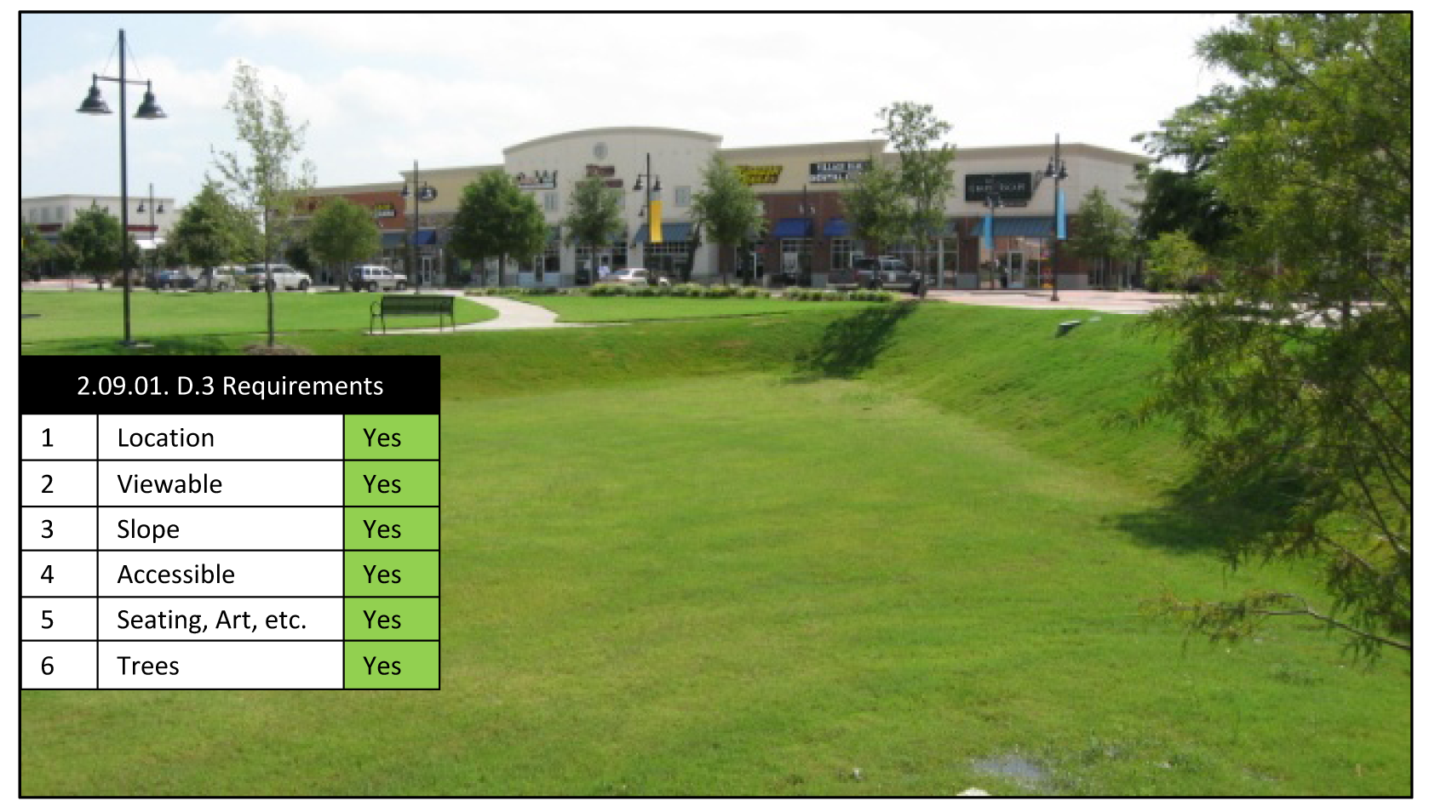
Figure 4: Example of a Detention/Retention Pond Designed as an Amenity
5. Example of a Detention/Retention Pond not Designed as an Amenity.
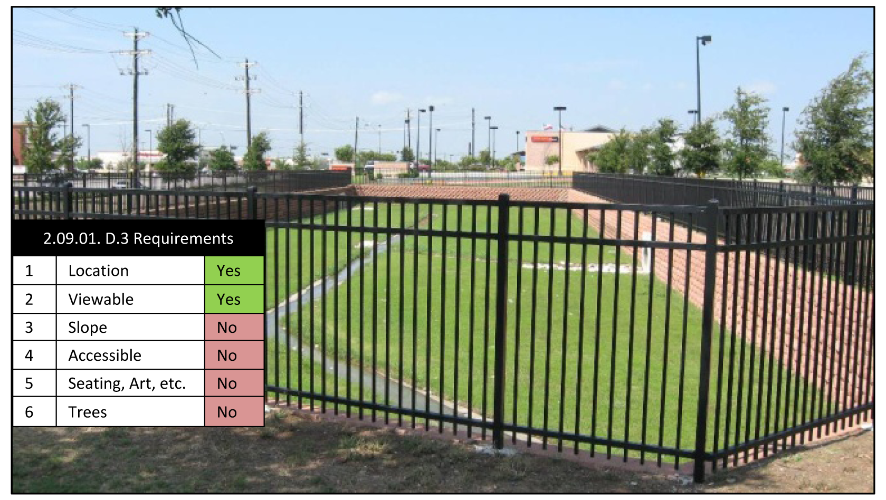
Figure 5: Example of a Detention/Retention Pond not Designed as an Amenity
E. Approved Plant Materials
1. The use of artificial plants or turf are expressly prohibited for compliance with this UDC.
2. Use of drought tolerant plants are encouraged to meet the requirements of this UDC.
3. The following is the approved plant material list for plant materials required in this UDC:
Table 15: Recommended Plant Material List
CANOPY (SHADE) TREES—HARDINESS ZONE 8
Common Name | Botanical Name | TX Native | Mature Height | Mature Spread | Light Req. | Water | Foliage | Util. Appr.
Ash, Texas | Fraxinus texensis | Y | 30' | 40—50' | Sun | VL | Decid.
Cedar, Eastern Red | Juniperus virginiana | Y | 20—50' | 15—25' | Sun | M | Everg.
Cherry, Escarpment Black | Prunus serotina var. eximia | Y | 25—50' | 25—35' | Sun/part shade | L | Decid.
Cypress, Arizona | Cupressus arizonica | Y | 20—50' | 15—25' | Sun | L | Everg.
Elm, American | Ulmus americana |  | 70—90' | 50—90' | Sun/part shade | M | Decid.
Elm, Cedar | Ulmus crassifolia | Y | 25—60' | 25—35' | Sun/part shade | L | Decid.
Elm, Lacebark | Ulmus parvifolia |  | 40—60' | 30—40' | Sun | M | Decid.
Locust, Honey (thornless) | Gleditsia triacanthos inermis | Y | 30—50' | 25—35' | Sun/part shade |  | Decid.
Maple, Big Tooth | Acer grandidentatum | Y | 40—50' | 20—30' | Sun/part shade | VL | Decid.
Mesquite, Honey | Prosopis glandulosa | Y | Y | 25-30' | Sun | VL | Decid. | Yes
Oak, Bur | Quercus macrocarpa | Y | 50—75' | 50'+ | Sun | VL | Decid.
Oak, Chinquapin | Quercus muhlenbergii | Y | 30—60' | 30-40' | Sun | M | Decid.
Oak, Lacey | Quercus laceyi | Y | 20—35' | 25' | Sun | VL | Decid.
Oak, Monterey (Mexican White) | Quercus polymorpha | Y | 40—60' | 30—40' | Sun | VL | Everg.
Oak, Escarpment Live* | Quercus fusiformis | Y | 20—40' | 50'+ | Sun | L-VL | Everg.
Oak, Shumard Red* | Quercus shumardii | Y | 30—50' | 30—50' | Sun | L | Decid.
Oak, Southern Live* | Quercus virginiana | Y | 30—50' | 50'+ | Sun | L-VL | Everg.
Oak, Texas Red* | Quercus texana | Y | 15—30' | 15—30' | Sun | L | Decid.
Oak, Post | Quercus stellata |  | 30—50' | 60—80' | Sun/part shade | M | Decid.
Pecan | Carya illinoiensis | y | 60—90' | 60—75' | Sun | M | Decid.
Pine, Italian Stone | Pinus pinea |  | 35—60' | 20—40' | Sun | L | Everg.
Sycamore, Mexican | Platanus mexicana |  | 30—50' | 40' | Sun/part shade | M-L | Decid.
Walnut, Texas Little | Juglans microcarpa | Y | 18—20' | 20' | Sun/part shade | M | Decid.

* May not be used in Oak Wilt prone area.
UNDERSTORY (SMALL) TREES—HARDINESS ZONE 8
Common Name | Botanical Name | TX Native | Typ. Height | Typ. Spread | Light Req. | Water | Foliage | Util. Appr.
Buckeye, Mexican | Ungnadia speciosa | Y | 8—15' | 12—20' | Sun/part shade | L | Decid. | Yes
Cherry Laurel | Prunus caroliniana | Y | 15—20' | 12—15' | Sun/part shade | M | Everg.
Chitalpa | Chitalpa tashkentensis |  | 25—30' | 15—20' | Sun/part shade | L | Decid.
Crapemyrtle | Lagerstroemia indica |  | 4—30' | 10—20' | Sun | L-M | Decid. | Yes
Desert Willow | Chilopsis linearis | Y | 10—25' | 15—20' | Sun/part shade | VL | Decid. | Yes
Dogwood, Rough-leaf | Cornus drummondii | Y | 8—15' | 10—15' | Sun/shade | M | Decid.
Eve's Necklace | Sophora affinis | Y | 10—20' | 15—20 | Sun/part shade | L | Decid. | Yes
Possumhaw | Ilex decidua | Y | 12—15' | 12' | Sun/part shade | L-M | Decid. | Yes
Holly, Yaupon | Ilex vomitoria | Y | 15—25' | 10—15' | Sun/part shade | L-M | Everg. | Yes
Mountain-laurel, Texas | Sophora secundiflora | Y | 10—20' | 8—12' | Sun/part shade | L | Everg. | Yes
Persimmon, Texas | Diospyros texana | Y | 8—15' | 8—12' | Sun/part shade | VL | Decid. | Yes
Pistache, Texas | Pistacia texana | Y | 10—30' | 30—45' | Sun/part shade | VL | Everg.
Plum, Mexican | Prunus mexicana | Y | 15—25' | 15—20' | Sun/part shade | L | Decid. | Yes
Redbud, Mexican | Cercis canadensis var. mexicana | Y | 15—30' | 12—15' | Sun/part shade | VL | Decid. | Yes
Redbud, Texas | Cercis canadensis var. texensis | Y | 15—30' | 12—15' | Sun/part shade | L | Decid. | Yes
Retama Palo Verde | Parkinsonia aculeata | Y | 12—20' | 12—20' | Part shade/sun | VL | Decid.
Sumac, Flameleaf | Rhus lanceolata | Y | 10—30' | 15—20' | Sun/part shade | L | Decid.
Viburnum, Rusty Blackhaw | Viburnum rufidulum | Y | 10—30' | 10—15' | Sun/shade | L | Decid.
Wax Myrtle | Myrica cerifera | y | 10—15' | 6—15' | Sun/part shade | M | Everg. | Yes

SHRUBS—HARDINESS ZONE 8
Common Name | Scientific Name | TX Native | Mature Height | Mature Spread | Light Req. | Water | Evergreen/Deciduous
LARGE (SCREENING)
Abelia Glossy | Abelia grandiflora |  | 6' | 6' | Sun/part shade | L-M | E
Acuba | Acuba japonica |  | 3—5' | 3—5' | Part shade | M | E
Cotoneaster | Cotoneaster sp. |  | 3—5' | 4—7' | Sun/part shade | M | E
Hawthorne, Indian | Rhaphiolepis indica |  | 4—6' | 4—6' | Sun/part shade | M | E
Holly, Burford | Ilex cornuta 'Burfordii' |  | 8—12' | 8—10' | Sun/part shade | L | E
Holly, Dwarf Burford | Ilex cornuta 'Burfordii Nana' |  | 4—6' | 3—4' | Sun/part shade | L | E
Holly, Dwarf Chinese | Ilex cornuta 'Rotunda nana' |  | 3—4' | 3—6' | Sun/part shade | L | E
Holly, Nellie R. Stevens | Ilex cornuta 'Nellie R. Stevers' |  | 8—10' | 5—6' | Sun | L-M | E
Holly, Dwarf Yaupon | Ilex vomitoria 'Nana' | Y | 2—4' | 2—4' | Sun/shade | L | E
Rosemary, Upright | Rosmarinus officinalis |  | 4' | 4—6' | Sun | M | E
Sage, Texas | Leucophyllum frutescens | Y | 4—5' | 4—5' | Sun | L | E
Wax Myrtle, Dwarf | Myrica pusilla; Morella cerifera var, pumila |  | 3—5' | 3—6' | Part shade/sun | M | E
Wax Myrtle, Southern | Myrica cerifera | Y | Shrub to 12' | 6—15' | Sun/part shade | M | E
Yucca, Spanish Dagger | Yucca rostrata | Y | 5—15' | 4' | Sun/part shade | VL | E
MEDIUM
Agave, Blue | Agave tequilana |  | 6' | 6' | Sun | VL | E
Agave, Century Plant | Agave americana | Y | 6' | 8—10' | Sun/part shade | VL | E
American Beautyberry | Callicarpa americana | Y | 4—6' | 6' | Part shade/shade | L-M | D
Cactus, Prickly Pear | Opuntia spp. | Y | 3—4' | 3—4' | Sun | L | E
Esperanza/Yellow Bells | Tecoma stans | Y | 4—8' | 4—6' | Sun | L-M | D
Flame Acanthus | Anisacanthus quadrifidus var. wrightii | Y | 3—4' | 3—4' | Sun/part shade | LD | D
Indigo Spires | Salvia 'Indigo Spires' | Y | 3—4' | 5—7' | Sun/part shade | L-M | D
Lantana, Texas | Lantana horrida | Y | 2—6' | 4—5' | Sun | VL | D
Palmetto, Texas Dwarf | Sabal minor | Y | 3—5' | 4—6' | Sun/shade | M | E
Rose, "Kock Out" | Rosa "Knock Out" |  | 3' | 3' | Sun | M | SE
Sage, Cherry (Autumn Sage) | Salvia greggii | Y | 2—3' | 2—3' | Sun | L | E
Sage, Henry Duelberg (Blue Sage) | Salvia farinacea "Henry Duelberg" | Y | 3' | 3' | Sun | L | D
Sage, Majestic | Salvia guaranitica |  | 3—5' | 4—5' | Sun/shade | L | D
Sage, Mexican Bush | Salvia leucantha |  | 4—5' | 4—5' | Sun | L | D
Sage, Russian | Perovskia atriciplifolia |  | 3' | 3' | Sun | L | D
Sotol, Texas | Dasylirion texanum | Y | 3—4' | 3—4' | Sun/part shade | L | E
Sumac, Fragrant | Rhus aromatica | Y | 6—9' | 4—6' | Sun/part shade | L | D
Turk's Cap | Malvaviscus arboreus | Y | 2—6' | 3—5' | Sun or shade | L | E
Yucca, Red | Hesperaloe parviflora |  | 6' | 4' | Sun | VL | E
Yucca, Softleaf | Yucca recurvifolia | Y | 4—6' | 3' | Sun/part shade | VL | E
SMALL
Agave, Parry's | Agave parryi | Y | 1—1.5' | 1.5' | Sun/part shade | VL | E
Agave, Queen Victoria | Agave victoriae-reginae | Y | 1.5' | 1.5' | Sun/part shade | VL | E
Artemisia | Artemisia 'Powis Castle' |  | 1—2' | 3—6' | Sun | VL | E
Coralberry | Symphoricarpos orbiculatus | Y | 2—3' | 2—3' | Sun/part shade | L | D
Sage, Scarlet or 'Tropical' | Salvia coccinea | Y | 1.5—3' | 1—1.5' | Sun/shade | L | D
Skullcap, Pink | Scutelleria suffrutescens |  | 1' | 3' | Sun/part shade | L | E
Yucca, Red | Hesperaloe parviflora | Y | 2—4' | 4' | Sun/part shade | VL | E

ORNAMENTAL GRASSES—HARDINESS ZONE 8
Common Name | Scientific Name | TX Native | Mature Height | Mature Spread | Light Req. | Water | Evergreen/Deciduous
Bluestem, Big | Andropogon gerardii | Y | 4—8' | 2—3' | Sun/part shade | L | D
Bluestem, Little | Schizachyrium scoparium | Y | 2—3' | 1-1.5' | Sun/part shade | L | D
Feathergrass, Mexican; Mexican Wiregrass | Nassella tenuissima | Y | 1—2' | 1-2.5' | Sun/part shade | L | SE
Fountain Grass, Dwarf | Pennisetum alopecuroides |  | 2.5—3' | 2.5-3' | Sun | M | D
Indiangrass, Yellow Indian Grass | Sorghastrum nutans | Y | 3—5' | 1-1.5' | Sun/part shade/shade | L | D
Inland Seaoats | Chasmanthium latifolium | Y | 1—3' | 3—6' | Part sun/shade | L-M | D
Muhly, Bamboo | Muhlenbergia dumosa |  | 4—5' | 4—5' | Sun/part shade | L | E
Muhly, Big; Lindheimer Muhly | Muhlenbergia lindheimeri | Y | 3—5' | 3—4' | Sun/part shade | M-L | D
Muhly, Deer | Muhlenbergia rigens | T | 1-1.5' | 1-1.5' | Sun/part shade | L | D
Muhly, Gulf | Muhlenbergia capillaris | Y | 2—2.5' | 2—3' | Sun/part shade | L-M | D
Muhly, Pine | Muhlenbergia dubia | T | 1—3' | 1—3' | Sun/part shade | VL | E
Muhly, Seep | Muhlenbergia reverchonii | T | 2—3' | 1.5—2' | Sun | VL | D
Nolina; Ribbon Grass, Devil's Shoestring | Nolina lindheimeriana | E | 1—3' | 4—5' | Sun/part shade | L | E
Rye, Canada Wild | Elymus canadensis | T | 2—4' | 2—3' | Sun/part shade | M | D
Sideoats Grama | Bouteloua curtipendula | Y | 1—3' | 2—3' | Sun/part shade | L | D
Switchgrass | Panicum virgatum | Y | 3—6' | 1—3' | Sun/part shade | M | D
Wheatgrass, Western | Pascopyrum smithii |  | 1—3' | 1—1.5' | Sun/part shade | M | D

PROHIBITED PLANT SPECIES*
Common Name | Scientific Name
Bamboo | Phyllostachys aurea; Bambusa spp.
Cat's Claw Vine | Macfadyena unguis-cati
Cattail | Typha spp.
Chinaberry | Melia azedarach
Chinese Parasol Tree | Firmiana simplex
Chinese Pistache | Pistacia chinensis
Chinese Tallow | Sapium sebiferum
English Ivy | Hedera helix
Giant Cane; Giant Reed | Arundo donax
Japanese Honeysuckle | Lonicera japonica
Jimsonweed | Datura stramomium
Jujube | Ziziphus zizyphus
Kudzu | Pueraria lobata
Ligustrum, Japanese | Ligustrum, lucidum
Ligustrum, Wax Leaf | Ligustrum japonicum
Mimosa (non-native) | Albizzia julibrissin
Mulberry, Paper | Broussonetia papyrifera
Mulberry, White | Marus alba
Nandina (fruiting varieties) | Nandina spp.
Oleander | Nerium oleander
Pampas Grass | Cortadenia selloana
Princess Tree; Empress Tree | Paulownia tomentosa
Pines, non-native | Pinus elliottii; P. eldarica, P. virginiana
Photinia, Chinese | Photinia spp.
Privet, Common | Ligustrum sinense, Ligustrum vulgare (and others)
Pyracantha | Pyracantha spp.
Russian Olive | Elaegnus angustifolia
Tamarsik, Salt Cedar | Tamarix spp.
Tree of Heaven | Ailanthus altissima
Vinca, Periwinkle | Vinca major & V. minor
Vitex, Lilac Tree; Chaste Tree | Vitex agnus-castus
Wisteria, Chinese | Wisteria sinensis (and others)

F. Approval of Alternative Landscaping A request for alternative landscaping may be submitted and acted upon in accordance with the accompanying site plan or planned development request. The City Council, or alternatively the Director of Planning and Development if the site plan or planned development amendment meets the criteria for administrative approval, may approve the following, based upon a finding that the proposed alternative meets the spirit and intent of this Section 2.09.01 Landscaping Regulations:
1. Location or Type of Required Landscape Material.
a. Alternatives or minor changes to the location or type of required landscape materials due to unusual topographic constraints, sight restrictions, siting requirements, preservation of existing stands of native trees or similar conditions, or in order to maintain consistency of established front yard setbacks.
b. These minor changes may vary the location of required landscape materials, but may not reduce the amount of required landscape area or the amount of landscape materials.
2. Required Landscaping Edges and Buffers.
a. Alternatives or minor changes to the required landscape edges and buffers along a street frontage if immediately adjacent properties on both sides (at side property lines) have a smaller or no landscape buffer strip, in order to maintain consistency between existing parking lot and drive aisle alignments.
b. If an alternative landscape edge or buffer is granted, an equal amount of landscaped area and trees shall be provided elsewhere on the site as may be deemed appropriate by the City Council.
3. Landscaping for Nonresidential Areas Adjacent to Residential Areas.
a. Partial or complete relief from the landscaping buffer requirement within 2.09.01. A.6, if the applicable lot is smaller than two (2) acres.
b. If an alternative buffer is granted, adequate screening shall be provided to ensure an equivalent buffer effect.
G. Entryways and Amenity Features within City Right-of-Way
1. Entryway or amenity features within City Right-of-Way may be developed under the responsibility of a Homeowners' or Property Owners' Association.
a. Documents shall be submitted, reviewed, and approved by the Director of Planning.
(Ord. No. 18-02-15-06, § 1, 2-15-18; Ord. No. 18-08-16-24, § 2.15, 8-16-18; Ord. No. 19-2-21-06, § 2.01, 2-21-19; Ord. No. 25-05-01-22, §§ 2.01—2.04, 5-1-25)

