2.09.07. - Lighting and Glare Regulations
A. Purpose The purpose of this section is to set forth the minimum criteria for the installation, use and maintenance of outdoor lighting, the purposes of which are to:
1. Preserve and enhance the lawful nighttime use and enjoyment of property;
2. Protect drivers and pedestrians on nearby travel ways from disabling glare from non-vehicular light sources that shine directly into their eyes and thereby impair safe travel;
3. Shield adjacent properties from nuisance glare and trespass light resulting from improperly directed and unshielded light sources;
4. Preclude or lessen light pollution; and
5. Promote efficient design and operation with regard to energy conservation.
B. Definitions
1. Foot-Candle. The amount of illumination provided by one lumen uniformly distributed on one square foot of surface.
2. Glare. Light emitting from a luminaire with an intensity great enough to cause annoyance, discomfort or loss in visual performance and visibility.
3. Illumination. The density of light (luminous flux or lumens) on a surface. It is the quotient of the luminous flux divided by the area of the surface, expressed in foot-candles.
4. Light Distribution. The luminance at all points on the illuminated surface from specified light sources at specified mounting heights and spacing.
5. Light Trespass. The unwanted lighting of adjacent properties from light sources intended for the proposed sites.
6. Lumen. The quantity of luminous flux intercepted by a surface of one square foot, all points of which are one foot from a uniform source of one candela. A one-candela source (i.e., one candlepower) provides 12.57 lumens.
7. Luminaire. A device or fixture containing a light source and means for directing and controlling the distribution of light from the source.
8. Luminance. The luminous intensity per unit projected area of a given surface viewed from a given direction for purposes of this UDC expressed in candelas divided by distance squared.
9. Mounting Height. The vertical distance of the light source from the illuminated plane.
10. Spacing. The horizontal distance between adjacent light sources.
C. General Standards All outdoor illumination shall meet the following conditions:
1. Shielding Required. All roadway, parking lot, and walkway luminaires shall be shielded so that substantially all the directly emitted luminous flux falls within the property line.
2. Luminous Flux Design. All exterior building floodlights shall be designed or retrofitted with shielding in a manner such that all of the luminous flux falls upon either the surface of the structure to be illuminated or on the ground.
3. Required Turning Off of Parking Luminaires.
a. All parking luminaires, except those required for security, shall be extinguished within one hour after the end of business hours and remain extinguished until one hour prior to the commencement of business hours.
b. Except for reasons of security, a maximum of twenty-five (25) percent of the total luminaires used for parking lot illumination may remain in operation during such period.
4. Required Turning Off of Building Luminaires.
a. All exterior building floodlights, except those required for security, shall be extinguished by 10:00 p.m. or within one hour after the end of business hours of the business served, whichever is later, and remain extinguished until one hour prior to the commencement of business hours.
b. For reasons of security, however, a maximum average level of five foot-candles at entrances and loading docks and one foot-candle on the rest of the structure is permitted.
5. Required Turning Off of Stadium Luminaires.
a. All stadium and all other exterior sports arena luminaires used for the purpose of illumination of the playing area shall be extinguished by 10:00 p.m. or immediately after the conclusion of the final event of the day.
b. The remainder of the facility lighting, except for reasons of security, shall be extinguished at 10:00 p.m. or within one hour after the event, whichever is later, and remains extinguished until one hour prior to the commencement of the next event.
c. For reasons of security, however, a maximum average level of five foot-candles at an entrance and one foot-candle on the rest of the structure shall be permitted.
6. No outdoor illumination shall be used in any manner that could interfere with the safe movement of motor vehicles on public streets, including:
a. Any fixed luminaire not designed for roadway illumination that produces incident or reflected luminous flux that could be disturbing to the operator of a motor vehicle;
b. Any luminaire that may be confused with or construed as a traffic control device; or
c. Any blinking, flashing, or changing intensity lights, except for temporary holiday displays.
7. Compliance for all Illumination. All outdoor illumination shall comply with the requirements of this section.
8. Strings of Lights Prohibited. No person shall use a string of lights on property with nonresidential uses except for the following:
a. Strings of lights may only be used if:
i. They are approved by a Site Plan.
(a) Such a plan must comply with all of the standards of this section.
(b) The purpose of such lighting shall be to create ambiance and pleasing pedestrian spaces in an energy efficient manner.
(c) Low wattage or low voltage fixtures and luminaires are required.
(d) Such lighting shall be limited to pedestrian areas including plazas, patios, landscape features, and primary entries into buildings.
(e) No such illumination shall be allowed in any required landscaped setback adjacent to a street; or
ii. For lighting displays from the last Thursday in November through the last Thursday in January.
b. Strings of lights permitted under this subsection may be displayed only on a building, on a wall or fence, on trees or shrubs, and on poles, but may not be suspended horizontally between such objects.
i. For the purposes of this paragraph, "horizontally" means any portion of the suspended string that dips less than forty-five degrees below the horizontal.
ii. All such strings of lights shall comply with the applicable electrical and building code provisions.
c. For the purposes of this subsection, "string of lights" means a series of lights attached to a light cord or wires in such a way that they can be moved about and hung in various ways, and whose bulbs are not in lighting fixtures permanently attached to a building or other structure.
9. Neon lighting.
a. Neon lighting may be used as a lighting element, provided that the tubes are concealed and are an integral part of the building design.
D. Exemptions The following uses shall be exempt from the requirements of this section:
1. Lighting, such as streetlights, traffic signal devices warning, or emergency lights/devices, installed by a governmental agency for traffic safety control purposes on public right-of-way or property.
2. Lighting that is not subject to this UDC by state or federal law.
3. Specific exemptions as may be recommended by the Planning and Zoning Commission and/or approved by the City Council during consideration of the Site Plan, provided the Applicant can demonstrate that strict compliance with these provisions would not contrary to the purpose and intent of this Section or that alternatives proposed by the Applicant would satisfy the purposes of this Section at least to an equivalent degree, or, if determined that the Section's provisions restricts illumination to a standard insufficient for safety (per recommended practices adopted by the Illuminating Engineering Society of North America) or other evidence submitted by a professional engineer. The City Council may impose such conditions that it deems appropriate to further the purposes of this Section.
E. Plans and Submittals
1. Lighting plans shall be submitted for review and approval concurrently with the Site Plan and shall include a schematic layout of all proposed exterior fixture locations, foot-candle data, and a plot demonstrating intensities and uniformities within the established limitation of this Section.
2. When requested by the Building Official or Responsible Official, the Applicant shall submit a visual impact photometric plan that demonstrates both light coverage and light spillage resulting from the proposed lighting plan and the provision for adequate measures to mitigate nuisance and unsafe conditions from light pollution and glare both uses or development on site and on adjacent properties.
3. Should any outdoor light fixture or the type of light source be changed after receiving approval pursuant to the approved Site Plan, the owner, or agents, shall submit a change request to the Building Official for his approval, together with adequate information to assure compliance with this Section.
F. Lighting Design
1. Lighting systems, including the placement of luminaries, shall meet the requirements of this UDC.
2. Luminaires on poles over 42 inches in height and exterior wall-mounted light fixtures shall be high-pressured sodium lights or other light giving a similar soft lighting effect. The Building Official may approve alternate lighting if he finds that it:
a. Provides at least approximate equivalence to the applicable specific requirements of the UDC; and
b. Is otherwise satisfactory and complies with the intent of this UDC.
3. Fully recessed lights in ceilings of canopies or roof overhangs may be of any type provided the level of illumination does not exceed the limitations specified in 2.09.07. G. See Figure 14: Ceiling Light in Canopy or Overhang (below).
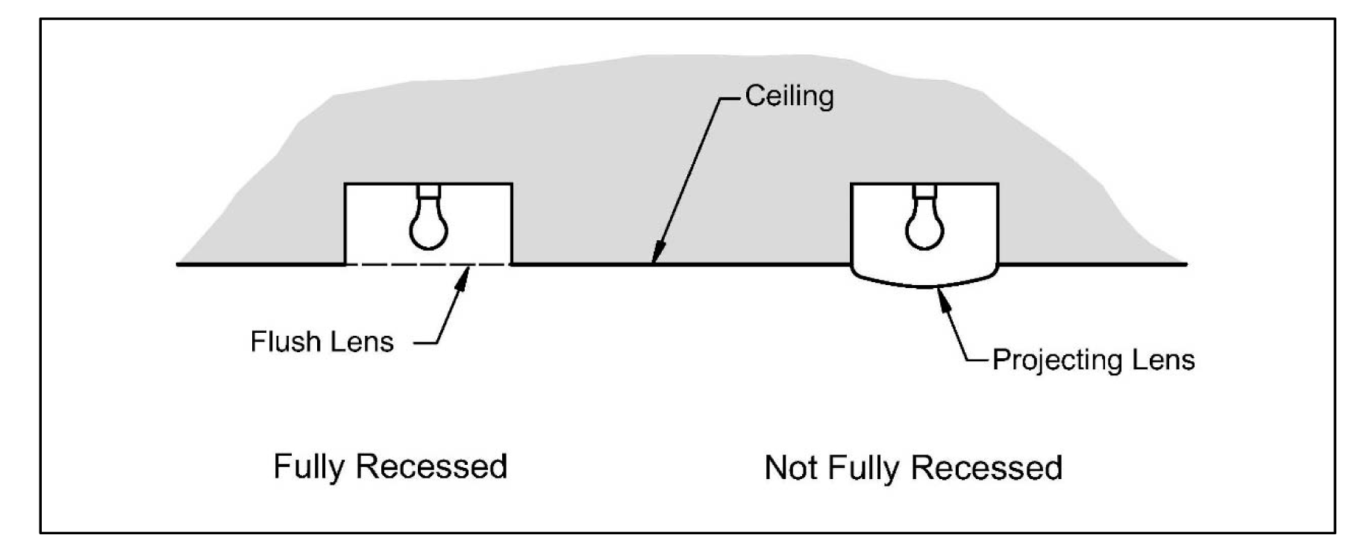
Figure 14: Ceiling Light in Canopy or Overhand
4. Luminaries causing glare at property lines or in vehicle areas on streets or parking lots are prohibited.
5. Incandescent bulbs may be used as decorative lighting provided the individual lamps do not exceed 25 watts and do not otherwise conflict with this UDC.
G. Illumination
1. Intensity of Illumination. The intensity of Illumination projected from one property to another property is determined by the zoning district classification of the adjacent property and shall not exceed the following intensities, as measured from the property line of the adjacent property:
Table 19: Maximum Illumination between Properties
Underlying Zoning of Adjacent Property | Foot-Candles  Horizontal | Foot-Candles  Vertical
Single Family (detached and attached) Residential Districts | 0.2 | 0.5
Multi-Family Residential Districts | 0.5 | 0.5
Commercial Districts, streets | 3.0 | 3.0
Industrial Districts | 5.0 | 5.0

2. Maximum Outdoor Illumination Level. The maximum computed or measured outdoor Illumination level on a property shall not exceed 20 foot-candles outdoors at any point, except that lighting under canopies (such as for service stations) shall not exceed 30 foot-candles.
3. Measurement of Illumination.
a. Meter required.
i. Lighting levels of outdoor lighting shall be measured in foot-candles with a direct-reading portable light meter with a color and cosine corrected sensor with multiple scales.
ii. Reading accuracy should be within ± five percent (5%).
iii. The meter shall be tested and calibrated by an independent commercial photometric laboratory or manufacturer within one year of date of use as attested to by a certificate issued by such laboratory.
b. Horizontal method of measurement.
i. The meter sensor shall be mounted not more than six inches above ground level in a horizontal position.
ii. Readings shall be taken only after the cell has been exposed to provide a constant reading.
iii. Measurements shall be made when the meteorological optical range is six miles or further so that measurements will not be adversely affected by atmospheric scatter.
iv. Measurements shall be made after dark with the existing questioned light sources on, then with the same sources off.
v. This procedure eliminates the effects of moonlight and other ambient light.
vi. The difference between the two readings shall be compared to the foot-candle ratings listed in Table 19: Maximum Illumination between Properties (above).
c. Vertical method of measurement.
i. The meter sensor shall be mounted at five feet above ground level in a vertical position, perpendicular to the property line and facing the outdoor lighting in question.
ii. Readings shall be taken only after the cell has been exposed to provide a constant reading. Measurements shall be made after dark with the existing questioned light sources on, then with the same sources off.
iii. This procedure eliminates the effects of moonlight and other ambient light.
iv. The difference between the two readings shall be compared to the foot-candle ratings listed in Table 19: Maximum Illumination between Properties (above).
d. Computation of illumination.
i. Illumination at a point may be computed in lieu of measurement.
ii. Computation methods shall consist of a generally accepted Illuminating Engineering Society method, using certified photometric data furnished by the fixture manufacture, lamp manufacturer, photometric laboratory, or other reliable authority satisfactory to the city. Computations shall be based on new, properly seasoned lamps, new and clean fixtures, and at rated voltage and wattage, with ballasts, lenses, shields, diffusers, and other appurtenances in place, and with proper regard taken for mounting height, relative elevation, natural and manmade objects.
H. Luminance
1. Limits. The intensity of Luminance projected from one property to another is determined by the zoning district classification of the adjacent property and shall not exceed the following limits:
Table 20: Maximum Luminance between Properties
Underlying Zoning of Adjacent Property | Luminance
Single Family (detached and attached) Residential Districts | 0.02
Multi-Family Residential Districts | 0.05
Commercial Districts, streets | 0.30
Industrial Districts | 0.50

2. Calculations (generally).
a. Because of the lack of a practical means of measuring fixture Luminance in the field, and because of the factors involved in glare, a computational method shall be used to determine compliance with this section.
b. The point from which luminance calculations shall be made is five feet (5') above ground at the property line of the property adjacent to the property with the outdoor lighting.
3. Luminance Calculations using Luminaries Photometric Data.
a. Luminance shall be computed by the formula:
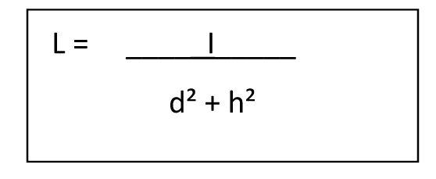
i. Where "I" is the fixture candlepower in candelas in the direction of the point from which the calculations are to be made,
ii. "d" is the shortest distance in feet measured horizontally from the property line to a point directly under the luminaries, and
iii. "h" is the height of the luminaries above the eye level as explained in the illustration below.
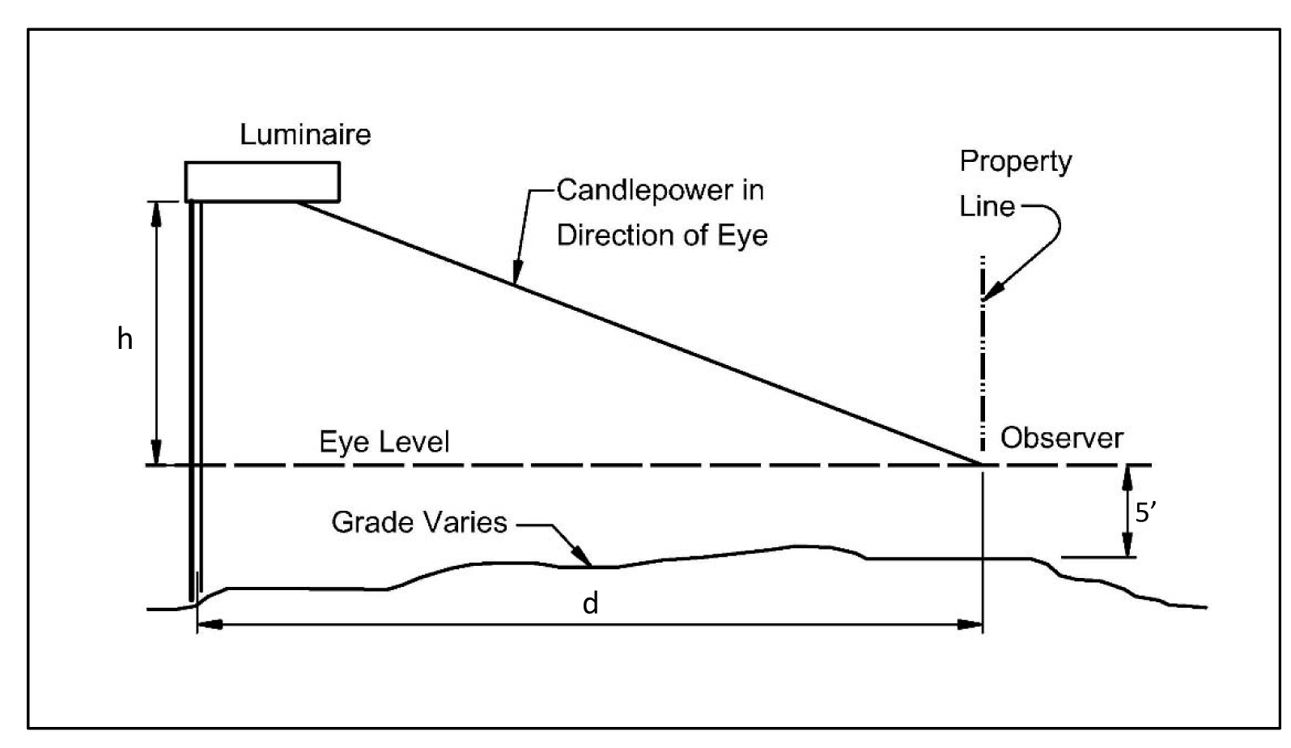
Figure 15: Factors for Luminance Determination
I. Enforcement
1. Illumination in Excess of Limits.
a. If the Illumination, as measured, exceeds the limits stated in the above section, the Illumination shall be reduced until the Illumination is equal to or less than the limits prescribed in Section 2.09.07. G.
b. This may be accomplished by removal of the light, reduction in the quantity of luminaries, reduction of the wattage of the lamps, shielding the luminaries or aiming of the luminaries.
2. Luminance in Excess of Limits.
a. If the Luminance of a luminaries, as calculated, exceeds the limitation in the above section, the Luminance shall be reduced until the Luminance is equal to or less than the limits prescribed in Section 2.09.07. H.
b. This may be accomplished by reduction of the wattage of the lamps, shielding the luminaries or by re-aiming of the luminaries.
3. Shielding.
a. Luminaries shall be aimed in such a manner that the viewer's eye, five feet above ground at or beyond the property line, shall not be exposed to fixture Luminance within the floodlight beam of the luminaries.
b. If such luminaries cannot be aimed they shall be shielded such that the light source is effectively concealed from view from the adjacent property.
c. Shielding may be accomplished by louvers, baffles, visors, or shields placed on the luminaries, or by plantings fences, berms, elevation or any other method such that the limitations of Section 2.09.07. H above are met.
J. Existing Lighting When outdoor lighting lawfully existed on the effective date of this UDC and which does not conform to the provisions of this UDC or when plans for outdoor lighting have been lawfully submitted in connection with an application for a building permit, or site plan before the effective date of this UDC, it shall be deemed a lawful use, subject to the following conditions:
1. If a person makes any change or addition to an existing lighting system, the change or addition shall conform to the provisions of this UDC; and
2. If a person makes any change or addition to an existing building that results in an increase in the size of the building by more than twenty (20) percent, the person shall ensure that the existing outdoor lighting shall conform to the provisions of this UDC.
K. Approval of Alternative Compliance A request for Alternative Compliance may be submitted to vary one (1) or more of the lighting-related regulations cited in subsections 2.09.07. K.1 through 2.09.07. K.4 below. A request for Alternative Compliance may be submitted and acted upon in accordance with 2.10.02. Alternative Compliance. The City Council may approve the following, based upon a finding that the proposed alternative meets the spirit and intent of this 2.09.07. Lighting and Glare Regulations in a manner equivalent or superior to the foregoing standards.
1. Height of free-standing lighting fixtures;
2. Style or illumination intensity of lighting fixtures (only if such fixtures are located at least three hundred feet (300') away from a residential zoning district or use);
3. Maximum wattage of accent lighting; or
4. Gaseous/electrified building lighting design.

