Pictures of Paramount Heights Sustainable Neighborhood – Demonstration Garden at Paramount Park in Wheat Ridge, CO
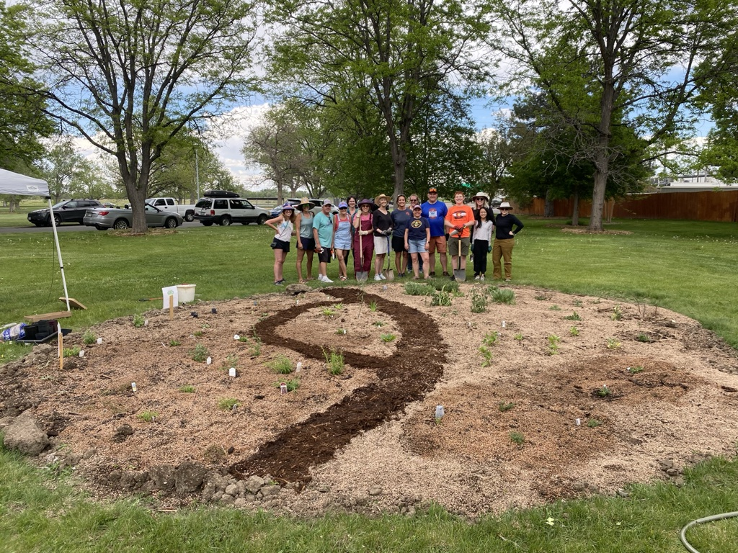
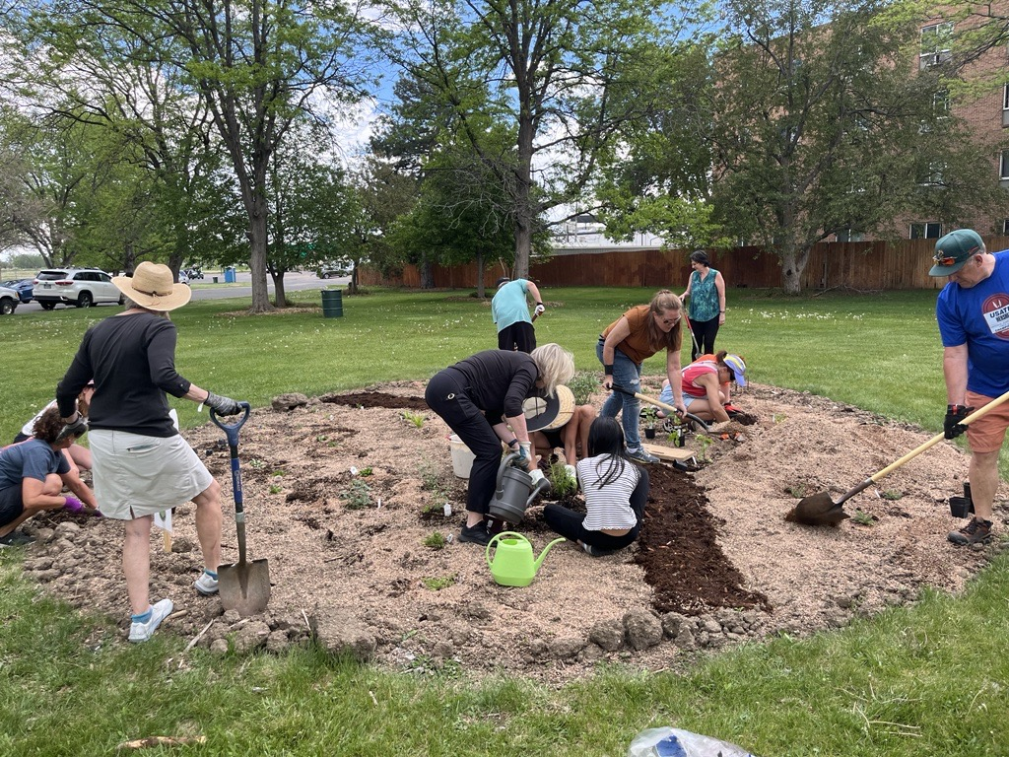
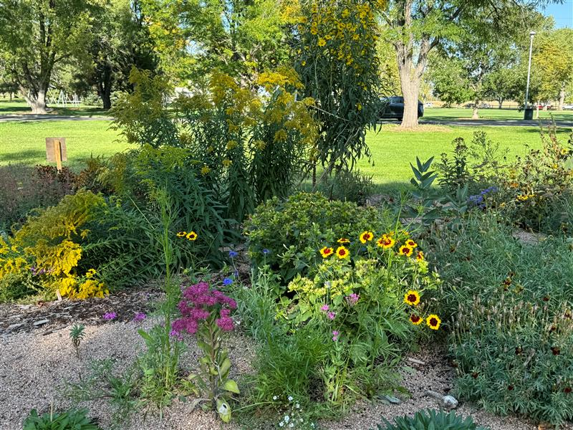

Picture from ribbon cutting with Mayor Bud Starker at the ribbon cutting for Panorama Park Sustainable Neighborhood’s garden in Panorama Park in Wheat Ridge, CO


