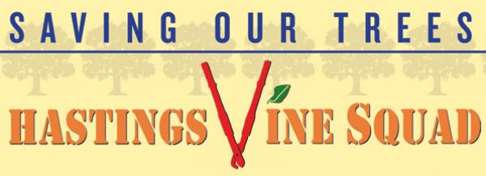
Saving trees since 2012
The Hastings Vine Squad is a group of resident volunteers seeking to preserve the health of our trees by removing invasive vines. The group has been active since 2012.

Typically the vine removal season runs every winter from November to March for about 12 weeks, and scores of volunteers are engaged in intensive 2-hr lopping sessions. The Vine Squad lops vines at the ground, and at 4’ or higher above the ground, and then returns the next season to cut back regrowth. The Vine Squad has worked on at least 25 acres of public space (most of which have been revisited several times over the years).

The vines encountered in Hastings-on-Hudson are mostly porcelain berry and Asiatic bittersweet, which were both imported from Asia over a century ago, and English ivy, imported from Europe in the 1700s. Porcelain berry takes over huge swaths of land, suffocating trees and extirpating native flora, while the fauna that relied on the native plants now face a landscape barren of the vegetation they need to survive. Bittersweet and English ivy strangle, weaken and eventually fell trees. Birds eat these vines' colorful berries, spreading them along their flyways and expanding the infestation. The berry-eating birds lose on nutrition, as fast-growing porcelain berries and asiatic bittersweet have more sugar and less fat than, for example, the native dogwood berries they have crowded out. Other invasive vines include:
- Asiatic wisteria
- Japanese honeysuckle
- Fiveleaf akebia, or chocolate vine
- Mile-a-minute

Local examples of vine removal and restoration efforts include the following:

1. The Hillside Woods Restoration Project, which is an ongoing, multi-year effort to restore habitat to our severely degraded hundred acre woods. Volunteers have removed hundreds of privet shrubs, over 450 Japanese barberry bushes and many invasive vines, with tree work on Norway maples, ailanthus trees and others via a contractor. To date, over 500 native tree and shrub seedlings have been planted across several acres. Approximate planted area is 15,000 square feet, with intensive invasive species removal in at least half an acre of distributed land. This project has received county and state funding and will include deer fencing.

2. Boutillier’s Brook Riparian Restoration Project, an ongoing collaboration with NYS DEC’s Trees for Tribs program, which has resulted in the removal of various invasives including Japanese knotweed, porcelain berry and other exotic vegetation along a local stream. In addition to vine removal, the project resulted in approximately one acre of native trees and shrubs being planted along a stream in the cleared areas. Volunteers cut back the knotweed, porcelain berry and other invasive plants on an ongoing basis. Groundwork Hudson Valley’s Green Team, a task force of teens involved in restoration work, have volunteered to keep the invasives at bay while the plantings are established.

3. The South County Trailway’s (SCT) restoration work, headed by local resident Steve Pucillo, is a volunteer-led effort to improve habitat and human infrastructure on the “Old Put” railway-turned-trailway. This paved trail runs from Yonkers to Croton and beyond, with about 1.5 miles running through Hastings-on-Hudson. Heavily trafficked, it is used by runners, walkers, rollerbladers and bicyclists. Steve has led numerous volunteers and also partnered with Groundwork Hudson Valley to remove invasive species along the length of the SCT Hastings – about 22 acres – with some additional work in neighboring jurisdictions. Steve and his volunteers have established five butterfly gardens along the Hastings stretch, which are labeled to inform passersby about the initiative.
4. The Burke Estate Wetlands Restoration Project is a citizen-led effort to restore habitat to Hastings-on-Hudson’s largest wetland, a neglected, spring-fed marsh full of phragmites and porcelain berry. The area is owned by the local school district, and the project engages high school students and their teachers. To date, over 3,000 square feet of phragmites has been cut back, and native trees and plants have been established in their stead in an area of approximately 2,000 square feet. NYS DEC has donated tree protection for 100 of the over 300 stems planted.
5. The “Saving Our Sidewalks” initiative on Lower Mt Hope Blvd. in concert with area neighbors. Below are photos that show the area before, during and after Vine Squad interventions.

Before | During | After
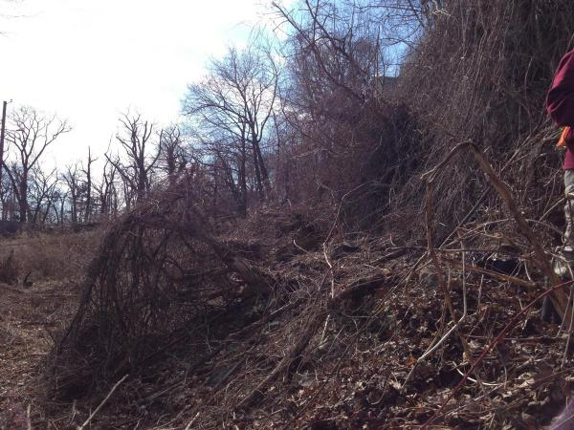 | 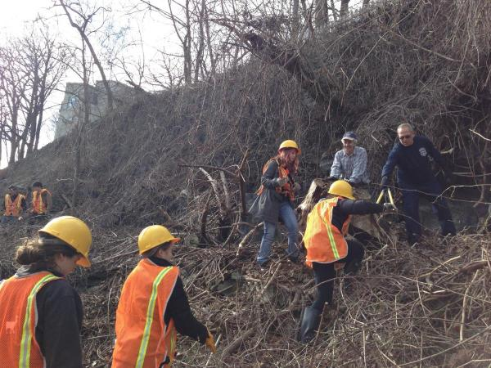 | 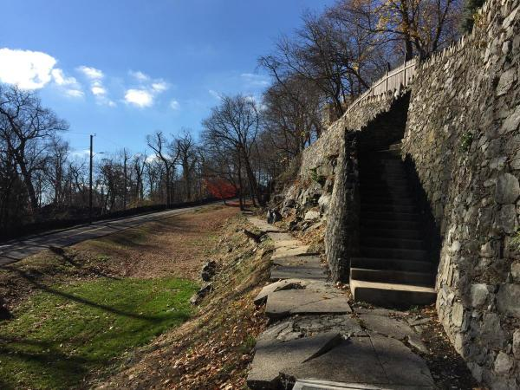

6. In 2024, members of the Mayor’s Climate Youth Council engaged in vine removal efforts in the Village that are described at these links: https://hohny.gov/674/Youth-Climate-Action-Fund---HoH-YCAF and https://www.hastingspollinatorpathway.org/home. Of note was:

Lantern Fly Trapforce – Tobias Navarrete and Marcus Galland – Hillside Woods
Tobias and Marcus used their grant to address the spotted lantern fly (SLF) invasion in Hillside Woods and Draper Park. They placed SLF traps at key "hotspot" locations where infestations and the tree of heaven had been identified (traps were positioned up the trees, see HERE to learn more). They aim to inform residents about the SLF, the tree of heaven, and prevention measures and plan to develop a mobile citizen science app to help residents report sightings of tree of heaven and SLF egg masses.

Hastings Invasive Plant Removal Initiative – Reuben Belasco and Nickola Horozov
Invasive plants are a major issue in Hastings, causing structural damage, crowding out native plants and destroying ecosystems. Ruben and Nickola used their grant to raise awareness and boost community removal efforts. They created a map of invasive plants in Hastings using crowdsourced data (thanks to the 322 people who contributed!) and they organized invasive removal efforts. They are in the process of creating a website which maps our invasives and we will be sure to share it when it is final. To learn more about their project see HERE.

