Hastings-on-Hudson Conversion of Vacant Lots to Monarch Habitat
Fiver Corners – Broadway and Chauncey Lane (Old Croton Aqueduct)
A vacant lot located at "Five Corners" in the Village of Hastings-on-Hudson, where Chauncey Lane and Broadway intersect, adjacent to the Old Croton Aqueduct trail, was converted into a monarch habitat by a group of local volunteers. The group included members of the Hastings Pollinator Pathways and the Hastings Beautification Committee.

In May 2021, the site was prepped (including removal of dead trees, mugwort and poison ivy), and in June and July 2021, volunteers began to plant a variety of native grasses and flowers and organized to ensure that the garden was watered during the hottest months of the summer. In June 2022, the garden was weeded. The garden is composed almost exclusively of native plants: 7 new native trees have been planted that serve as host plants to over 500 species of native butterflies, moths, and birds, as well as over 1,550 plants of grasses, shrubs, and nectar-producing perennials - including 30 Asclepias incarnata and Asclepias tuberosa milkweed plants. The newly created pollinator garden is approximately 1,750 square feet (.04 acre) (current information about the site can be found HERE).

Photos illustrating the transformation are available below: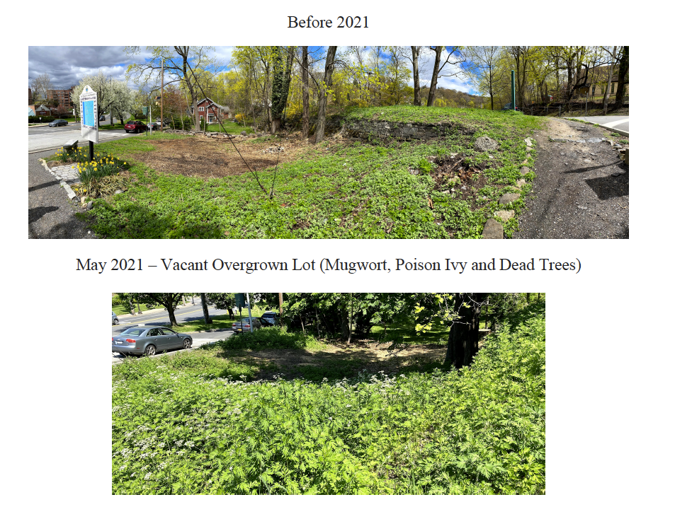
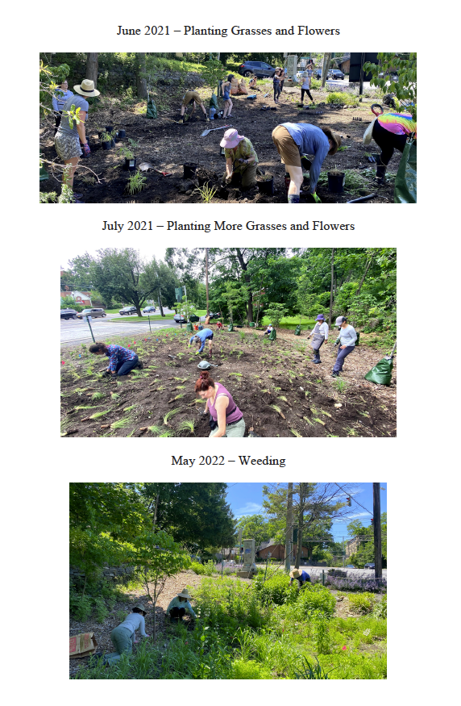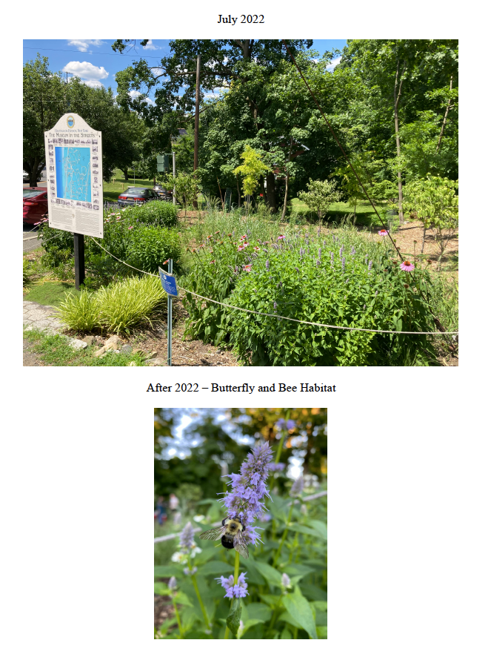
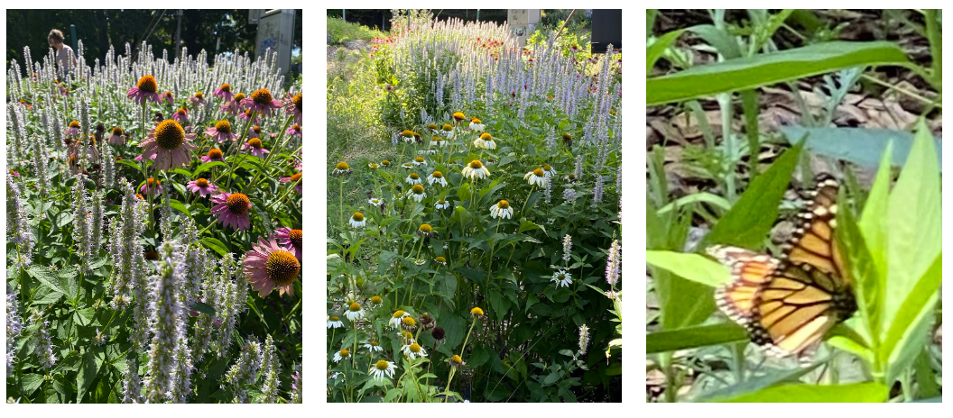

May 2023 – Expanding the Plantings, Weeding and Maintenance
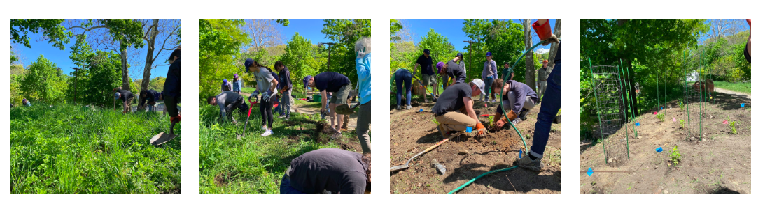

October 2023 – Garden in Bloom!
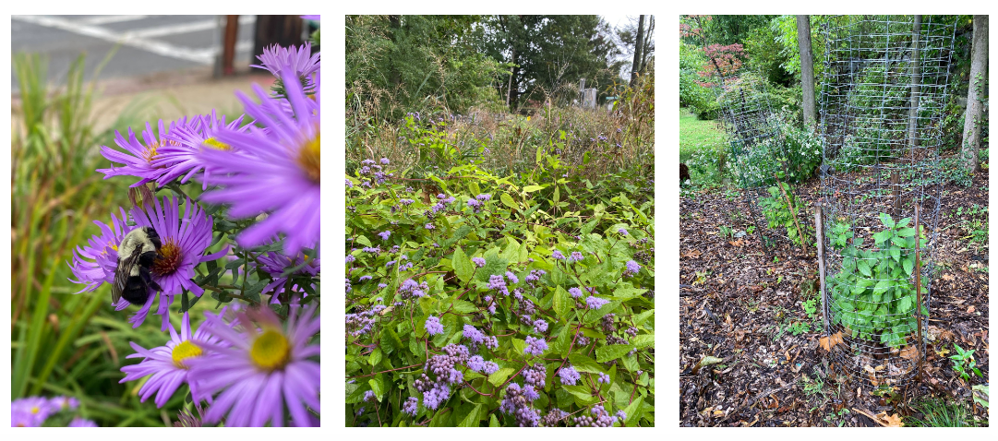
June 2024
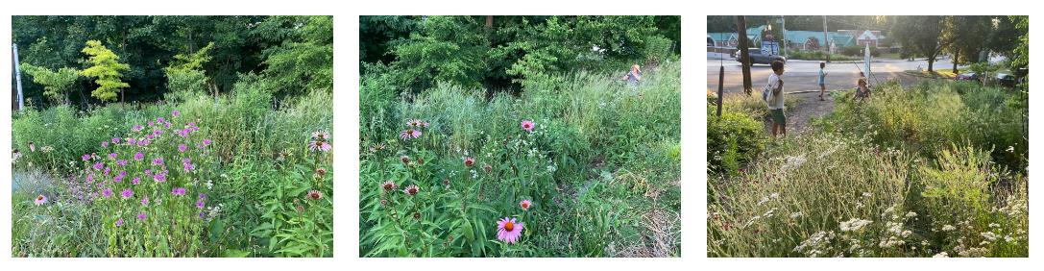

September 2024 – More Ongoing Maintenance


