Buzzing with Life:
Join the Parks for Pollinators Bioblitz and Celebrate Nature's Best Workers!

As summer fades to fall, each species responds uniquely to the changing environment. As days shorten and temperatures drop, leaves fall and plants wither, reducing the food available for other creatures. Birds, insects and animals must adapt by migrating, hibernating, or finding alternate sources of sustenance.
Here’s another opportunity to participate in what scientists refer to as phenology - the study of the timing and cyclical patterns of seasonal events in the natural world. So, how about getting outdoors in the month of September to see what’s happening during the Parks for Pollinators Bioblitz!
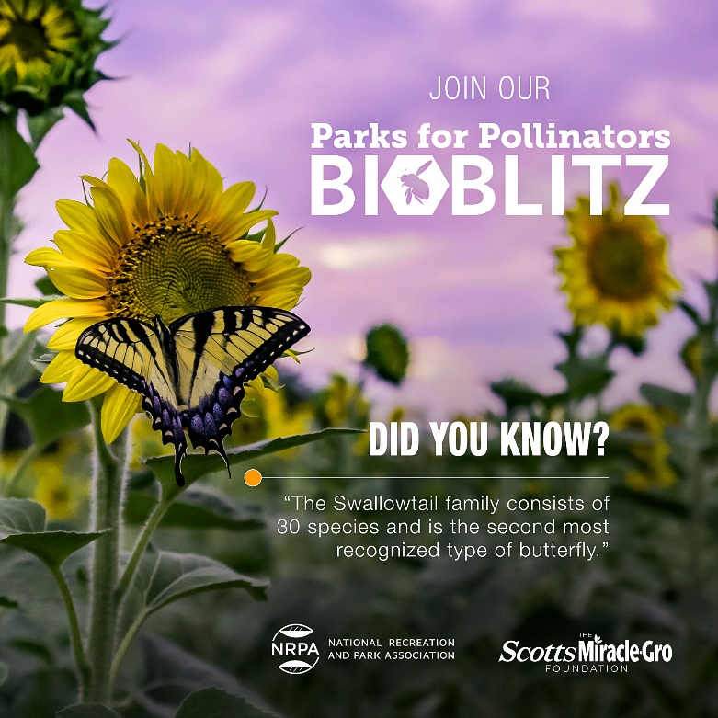
A BioBlitz is a community-wide effort to identify as many species of plants, animals and organisms as possible in a specific area and time frame. This is a hands-on approach to biodiversity assessment, offering everyone the chance to explore and document the natural world in real time. The Parks for Pollinator BioBlitz, hosted by the National Recreation and Park Association, is comprised of staff and members of the community working together to create a snapshot of the variety of life in US Parks.
Through the power of observation, the data collected by the community can demonstrate the biodiversity of our local parks and provide park professionals with important information on how to manage these spaces to support pollinators and other species that have faced steady decline over the last 30 years. We need your help in capturing the remarkable pollinators and host plants that call The Woodlands home!

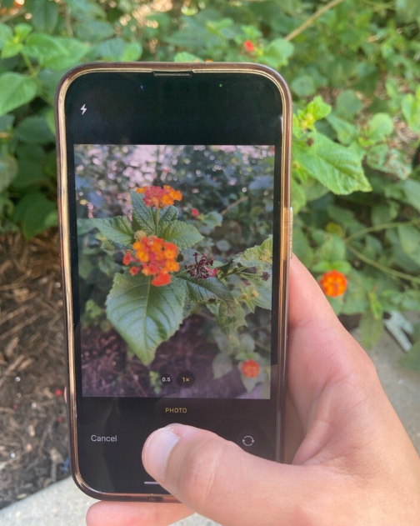
How you can participate in Parks for Pollinator BioBlitz 2024:
- Download the iNaturalist app onto your phone or tablet.
- Familiarize yourself with the app by watching a tutorial, or dive right into taking photos of critters, insects or plants and upload them via the iNaturalist app.
- Join our iNaturalist project by entering “Parks for Pollinators 2024: The Woodlands Township” under projects in the search bar on the iNaturalist app.
- Get outside and pay attention to nature! Add as many photos as you want all week long and upload them to our project.
- Have fun learning!

Share your remarkable findings and sightings with residents and experts at our Pollinator Booth as part of the 27th annual Woodlands Landscaping Solutions on Saturday, September 28 from 9 a.m. to noon, located at the Recreation Center at Rob Fleming Park.
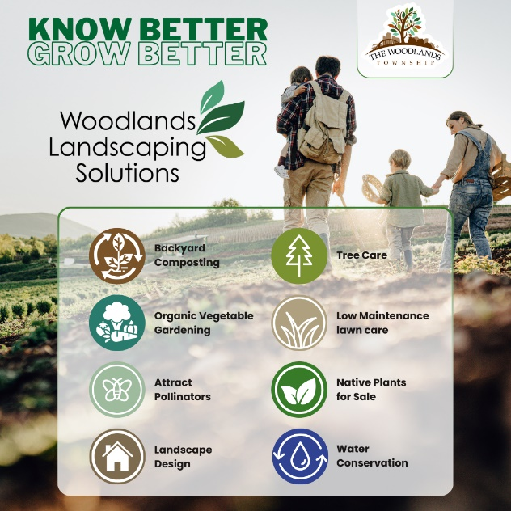
With any questions about how to participate in this event, please reach out to Environmental Services at 281-210-3800 or enviro@thewoodlandstownship-tx.gov.

